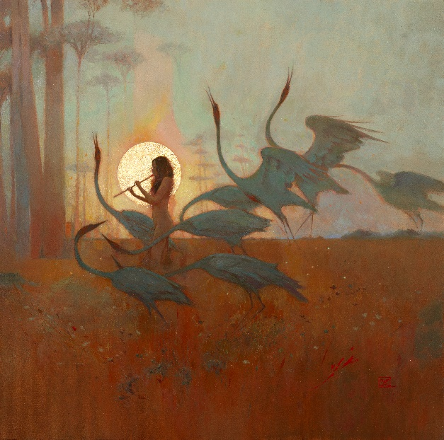

ALCEST
Les Chants de l'Aurore
JUNE 21ST 2024
Line up:  Neige – vocals, guitars, bass, synths  Winterhalter – drums | ALCEST online:  facebook.com/alcest.official  instagram.com/alcestofficial  twitter.com/alcestofficial
“The place where I’m taking my inspiration from is a place of pure harmony and light. I’m just like everyone else – I’m very anxious, I have my issues and demons, but there is a place inside me which is much more in peace and harmony, so I took inspiration from this part of myself, rather than the dark part.”

As the world we live in grows darker and more bewildering with every passing day, the transformative power of music has never been more vital. Formed in the small French town of Bagnols-sur-Cèze at the dawn of the century, underground icons Alcest have always been clear about their desire to transport listeners to somewhere different, somewhere better. Led by founder and multi-instrumentalist Neige, the French artists have been one of the most consistently radical voices in all of heavy music, with a sound that eschews metal’s often myopic devotion to casting shadows, in favour of a sublime blend of darkness and blinding bright light.

The release of Alcest’s debut album Souvenirs d’un Autre Monde in 2007 blazed a unique trail through the underground metal world, eliciting high praise and feverish condemnation in equal amounts. Ostensibly a black metal project, Neige’s crew gifted an entirely new perspective to the black metal scene: wherein beauty, fragility, melody and positive vibrations co-exist with the fast, furious aesthetic of true extreme metal. Almost instantaneously influential, Alcest were able to steadily establish themselves as a unique force, both with a series of acclaimed albums and a sturdy reputation as a transcendent live act.

From the enlightened primitivism of 2010’s Écailles de Lune, and the definitive, holistic squall of Les Voyages De L’Âme (2012), to the magical, post-rock splendour of Shelter (2014) and the dark, dynamic Kodama (2016), Neige’s vision has been presented in the most vibrant and revelatory colours. Meanwhile, the legions of like-minded “blackgaze” bands that have followed in Alcest’s wake speak volumes about the Frenchmen’s profound and enduring influence.

Released in October 2019, Alcest’s sixth studio album marked another grand milestone in their story. Their first record for Nuclear Blast Records, Spiritual Instinct deftly sustained the conceptual and musical preoccupations of past achievements, while taking Neige and long-time drummer Winterhalter into new sonic realms, both grittier and more nuanced than ever before. Inevitably, plans to tour their new music were eventually scuppered by the global pandemic that broke out early in 2020. But Alcest’s creative journey continued regardless, and the results can be heard on the band’s latest album, Les Chants de l’Aurore.

“I guess all musicians have more or less the same story to tell,” says Neige. “We did one tour in Europe for the release of the last album, and we were able to play the last show in Paris, but two days later, there was the lockdown. We had to cancel all our plans to tour in the States and everywhere else. But we’d been touring so much for the previous 10 years that it felt like a forced but necessary break, for me to just be able to be at home and focus a little bit on my family, my friends and myself. It was quite life-changing, to be obliged to stay at home. You had to review all your perspectives, you know? They were strange times, but now it almost feels like it didn’t happen…”

Having redirected his artistic energies, Neige began work on the follow-up to Spiritual Instinct, newly inspired by the experiential essence that first led him to his band’s ground-breaking musical life. As with Souvenirs d’un Autre Mode, Les Chants de l’Aurore draws inspiration from the spiritual childhood experiences that have shaped Neige, both as a musician and a human being. A liberated nosedive into the very notion of consciousness and the layered mists of reality, the seventh Alcest album amounts to a euphoric homecoming.

“I needed to go back into my inner world,” Neige says. “That’s where most of my resources and most of my inspiration for Alcest comes from. The last couple of records were quite dark, because they were influenced by things that were happening around me, like the terrorist attacks in Paris. We are living in very dark times. For the new album, I wanted to do the opposite – to bring a little bit of light into this world. Everything is so dark, and I find that light and beauty are not things that are very familiar anymore, especially in metal music. But my inner world is very bright and uplifting, and I thought it would be nice to make a record around this. Despite the overall style of the album, all the songs have their own themes and individuality, exploring different facets of Alcest's concept. This album is a journey with a beginning and an end that should be listened to as a whole, bringing the listener to various musical landscapes and emotions.”

Recorded by Neige and Winterhalter themselves, with a little help from talented friends, Les Chants de l’Aurore pulls off the neat trick of sounding both huge and intimate. From the opening Komorebi onwards, Alcest sound reborn and revitalised, as their most cherished trademarks are reinvented for a new era, and with new depths and sophistication on display.

“We bought some new equipment, and we recorded the album like bands were doing it in the ‘70s,” Neige explains. ”We went into this big house, and the drums were recorded in this big attic, with a really nice reverb! So it was interesting to do it ourselves, because we could spend as much time as we wanted to, to perfect the takes. We wanted some really organic production, but also I wanted this orchestral approach, with lots of arrangements and different kinds of sounds, like real piano and real choirs. It was quite an ambitious recording.”

A band known for their empathetic ethos, Alcest have never sounded more blissful than they do on Les Chants de l’Aurore. As Neige explains, new songs like recent single L’Envol and the epic L’Enfant de la Lune aim to counteract the negativity and darkness that surrounds us in the so-called real world, with hazily expressed visions of a different place and time. After dealing with the abstract horrors of mortal existence on previous records, Neige has returned to the comforting cocoon of his spirituality, and with the specific intention of spreading some love and positivity.

“This album is really coming back to the original concept of Alcest,” he notes. “It’s really about exploring this other world, in the same way that I wrote about it on the first album. The music should be a key to open the door to this other world. It’s like a gate to something else, and it’s a place that is the most beautiful thing you could imagine… but it’s difficult to describe, so that’s why I choose to make music. Because music can speak much more than words. There is a lot of beauty in it, as opposed to what is happening in the world, and I guess it touches people. I’m very thankful for that.”

Five years after their last album, Alcest have reconvened with a refreshed perspective on their epoch-altering musical endeavours. Les Chants de l’Aurore arrives at a tumultuous point in human history, laden with gentle charm and ferocious conviction, and doggedly determined to push Neige’s musical identity ever further into an expansive future. More importantly, perhaps, Les Chants de l’Aurore gives Neige a fresh opportunity to connect with his adoring fan base, armed with some of the most beautiful and mesmerising music that he has ever written.

“We always put all of our heart and soul into making a new record, but when it is released, it doesn’t belong to us anymore,” Neige shrugs. “People will decide if they like it or not, and that’s it, but I really love this album and I have a very special attachment to it. I’m never going to say ‘It’s the best fucking thing!’ [Laughs] That’s not our style, you know? But from the perspective of the latest feedback and the excitement people have expressed, I think it’s going to be great. We’ve got a 35-show tour booked for the end of the year, and we’ll play in some really nice venues, like the Olympia in Paris, the most iconic venue in Paris. Even the Beatles and the Rolling Stones played there! I’m so excited and honoured to play there. Then we will do the States and Asia next year, I hope. We don’t release albums very often, and this one took five years, so I think we’re going to tour a lot over the next three years.”

